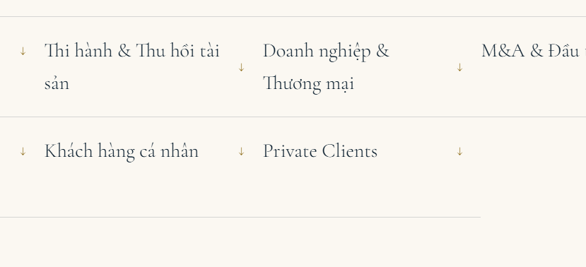 | 1. Bản VI: Page “Chuyên môn”: Ở chỗ list các lĩnh vực đầu trang  -Bỏ “Private client” dùm chị nha, tại có “Khách hàng cá nhân” rùi  - Bổ sung thêm lĩnh vực “Hình sự”
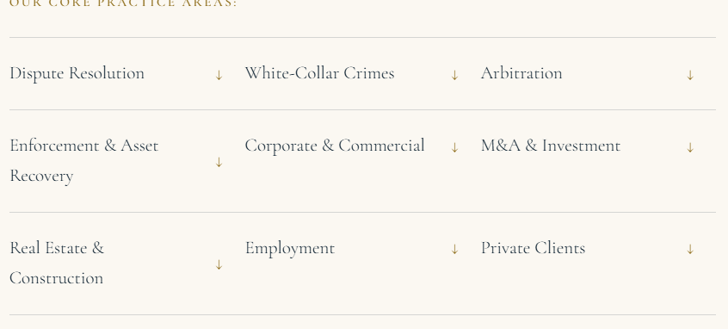  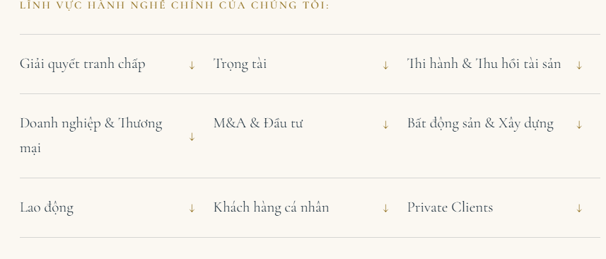 | 2. Sau khi em hoàn thành phần ở trên r:  - Trong bản VI, em sắp xếp lại các lĩnh vực theo đúng thứ tự như bản EN nha
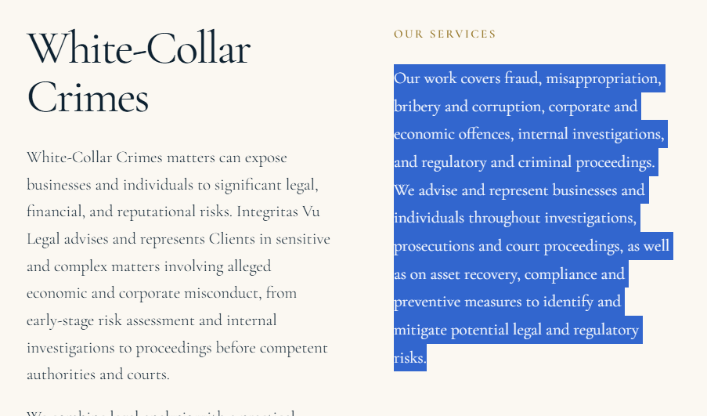 | 3. Bản EN:  - Ở phần mô tả ở dưới của lĩnh vực hình sự, chỗ Our services em thay nội dung thành list các dịch vụ cụ thể sau:  + Criminal law consultancy  + Early participation in legal proceedings  + Defending the accused and defendants  + Protecting the legitimate rights and interests of other involved parties  + Other legal support services  -Tương tự cho bản VI là:  + Tư vấn pháp luật Hình sự  + Tham gia tố tụng từ sớm  + Nhận bào chữa cho bị can, bị cáo  + Bảo vệ quyền và lợi ích hợp pháp cho các đương sự khác trong vụ án  + Dịch vụ pháp lý khác
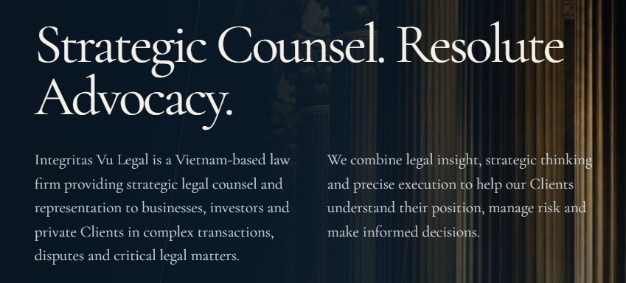 | Bản En: ở trang HOME  - Em sửa lại content thành:  “Integritas Vu Legal LLC (Integritas Vu Legal) is an independent boutique law firm in Vietnam, providing strategic legal advice and representation to businesses, investors, and private Clients.  With a strong focus on dispute resolution and a comprehensive approach to corporate and commercial matters and White-Collar Crimes, we deliver tailored legal solutions that address our Clients' priorities, anticipate risks, and protect their interests.”
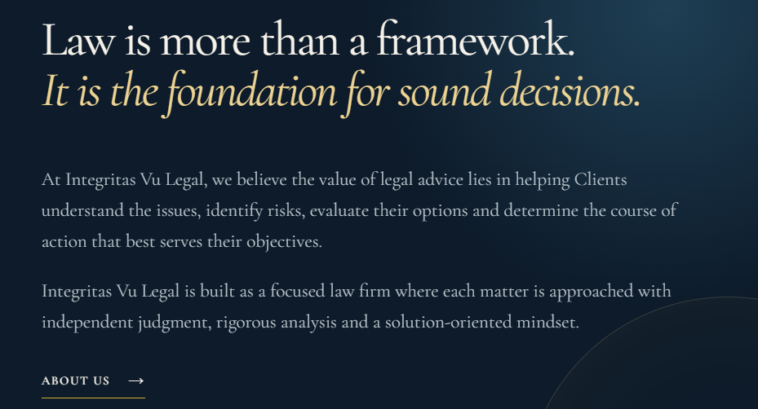 | Đổi ndung lại thành:  - Section này có tên là “OUR PERSPECTIVE”  - Ndung mới:  “Beyond Legal Advice. Towards Strategic Solutions.  Effective legal counsel requires more than an understanding of the law. It demands sound judgment, commercial awareness and the ability to navigate complex legal challenges with clarity and precision.  At Integritas Vu Legal, we look beyond immediate legal questions to understand the broader implications of every decision. Whether advising on a transaction, managing legal exposure or resolving a dispute, we develop strategies tailored to each Client's circumstances and objectives.  Our commitment is straightforward: to provide independent advice, thoughtful solutions and dedicated representation at every critical stage.  CTA: DISCUSS OUR FIRM”
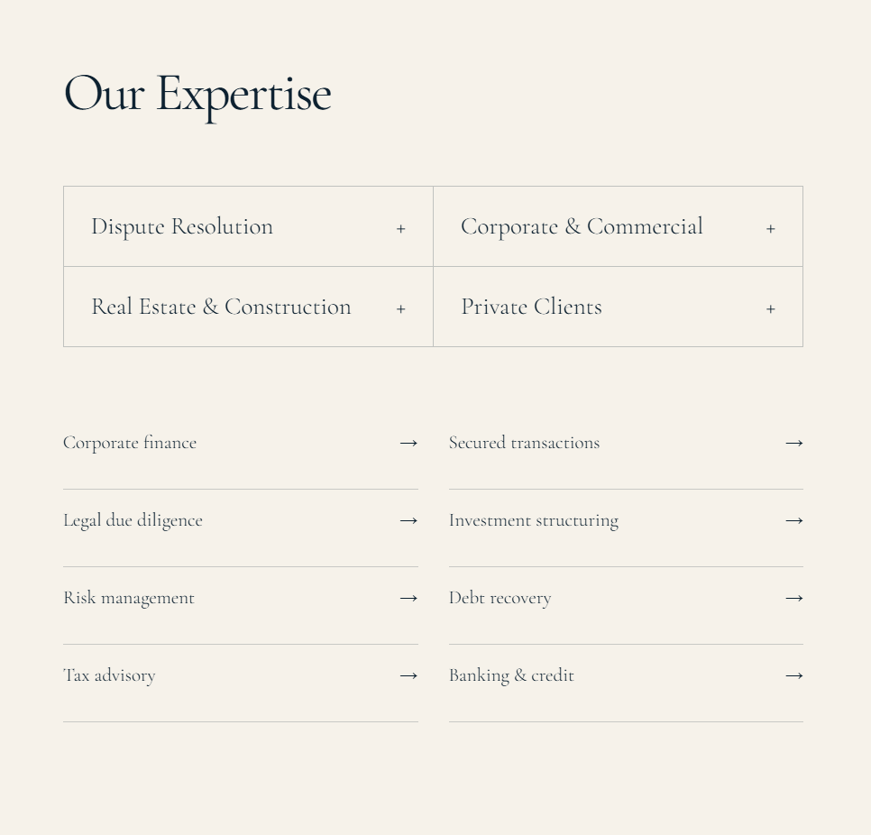 | Vẫn còn ở trang HOME bản EN:  - Sau dòng OUR EXPERTISE sẽ có dòng ndung: “We advise and represent Clients across a range of contentious and non-contentious matters, combining rigorous legal analysis with a practical understanding of business and individual needs.”  - Các lĩnh vực cụ thể bao gồm:  “Dispute Resolution & Arbitration  Strategic representation in complex civil, corporate and commercial disputes, from negotiation and litigation to arbitration and enforcement.  Corporate & Commercial  Practical legal counsel on corporate governance, commercial transactions, contractual arrangements and business-related legal risks.  White-Collar Crimes  We combine legal analysis with a practical understanding of business operations and evidentiary issues to develop a clear strategy, protect our Clients’ legitimate interests and manage risks throughout each stage of the matter.  Mergers, Acquisitions & Investment  Tailored advice on investment structures, acquisitions, transactions and regulatory matters involving domestic and foreign investors.  Real Estate & Construction  Legal support for property transactions, construction projects, contractual arrangements and related disputes.  Employment  Strategic advice on employment relationships, workplace compliance, executive matters and labour disputes.  Private Clients  Discreet and considered legal representation in significant personal, civil, property and inheritance matters.  CTA: VIEW ALL PRACTICE AREAS”  - C muốn khi khách bấm vào dấu cộng thì sẽ có 1 2 dòng review về lĩnh vực đó
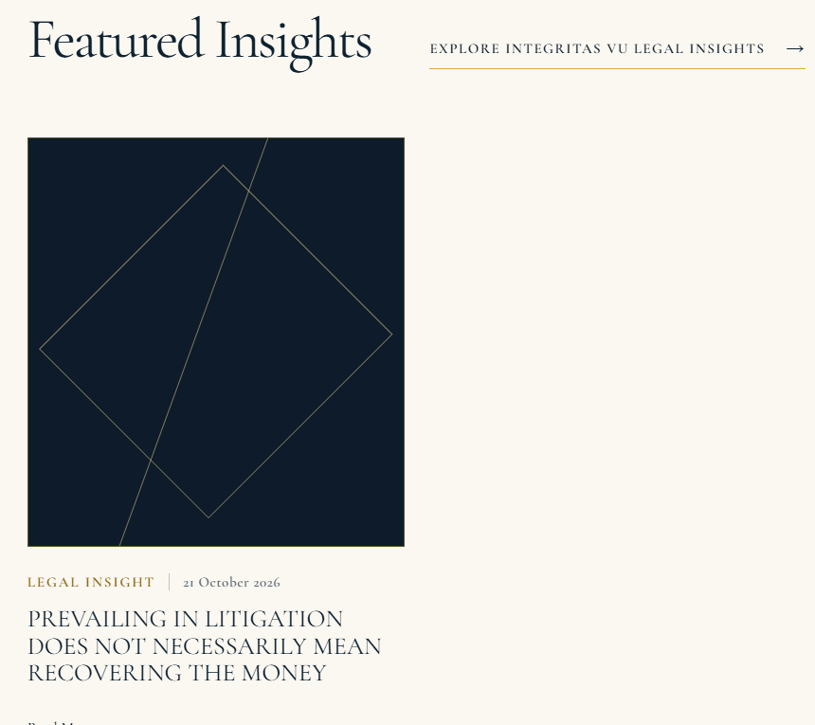 | Chị đã nói với Nhi là mình sẽ có hình để gắn lên bài ở website. Các bài đăng sắp tới e sẽ gắn hình tương ứng vô từng bài dùm c nha  - Có dòng giới thiệu dưới featured Insights:  “Legal Perspectives. Practical Implications.  Explore our perspectives on legal developments, emerging risks and issues affecting businesses, investors and individuals in Vietnam.  Through our legal insights, we aim to make complex legal matters more accessible while offering practical considerations to support informed decision-making.”
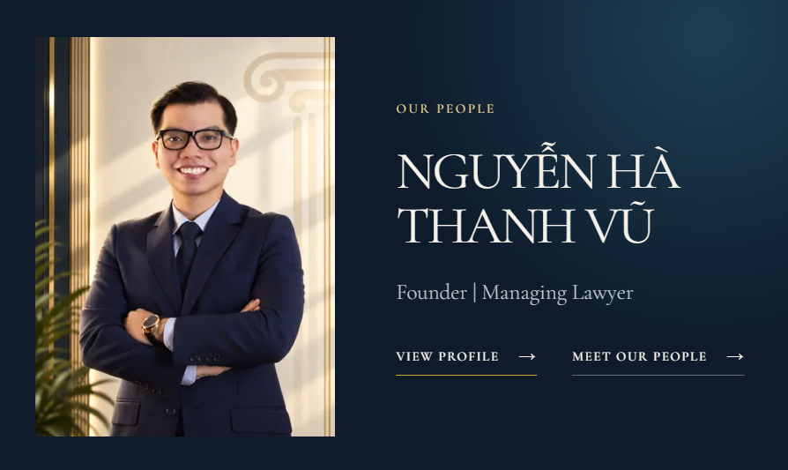 | Trang HOME, bản EN:  - Có dòng giới thiệu  “Personal Commitment. Professional Judgment.  At Integritas Vu Legal, we believe that the quality of legal representation begins with the people entrusted with each matter.  Our boutique structure enables direct lawyer involvement, close Client communication and an approach shaped by the specific circumstances of every engagement.  We value the trust placed in us and approach each matter with independence, diligence and a clear sense of professional responsibility.”  - Tên anh Vũ sửa thành: NGUYEN HA THANH VU (VICTOR NGUYEN)
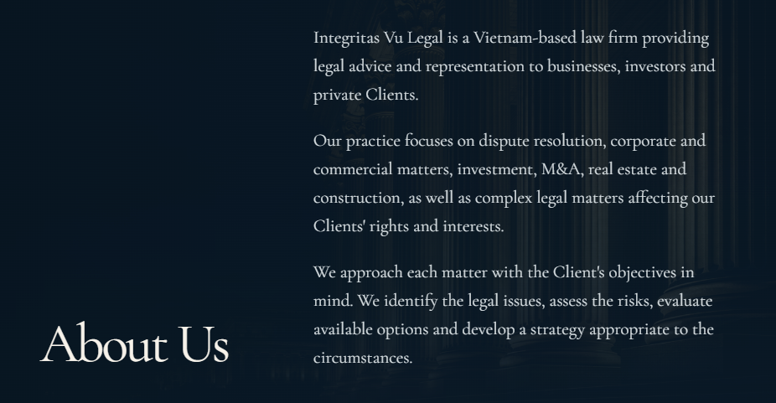 | Trang ABOUT US:  Content sửa thành:  About Integritas Vu Legal  Integritas Vu Legal is an independent boutique law firm based in Ho Chi Minh City, Vietnam, providing legal advisory and representation services to domestic and international businesses, investors and private Clients.  Our practice encompasses dispute resolution, litigation, arbitration, white-collar crimes, corporate and commercial law, mergers and acquisitions, foreign investment, real estate, construction and other significant legal matters.  We believe that effective legal representation requires more than technical expertise. It calls for independent judgment, strategic foresight and a thorough understanding of the Client's circumstances, priorities and long-term interests.  With this philosophy at the core of our practice, we strive to deliver legal services that are precise in execution, practical in application and tailored to the complexities of each matter.
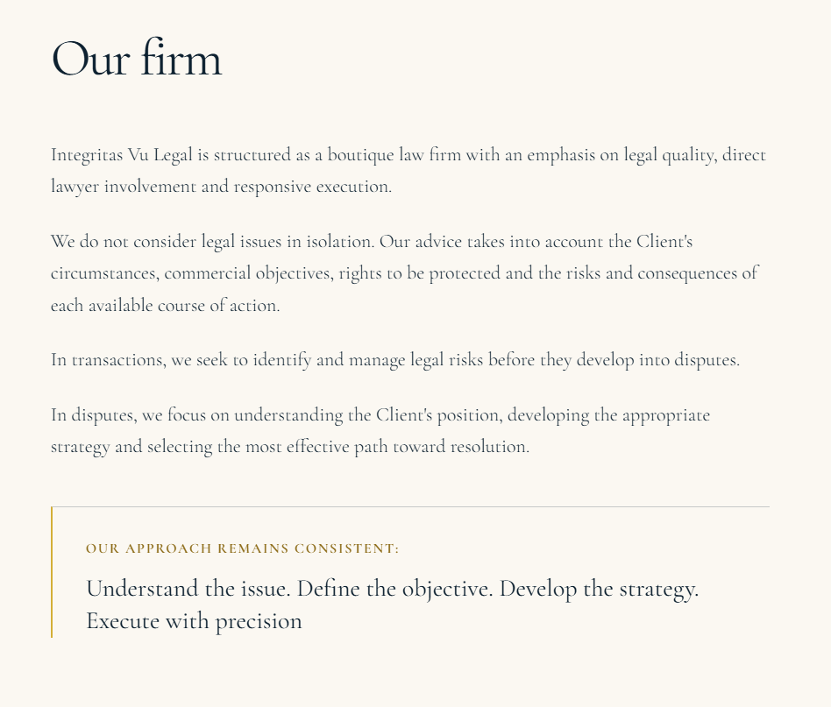 | Đổi content thành:  A Boutique Practice. A Distinctive Approach.  Integritas Vu Legal was established with a clear vision: to build a focused legal practice where professional judgment, personal commitment and the quality of legal services take precedence.  We recognise that no two Clients face precisely the same legal challenges. A commercially sound solution for one business may not be appropriate for another. Likewise, a dispute cannot be effectively addressed without understanding the underlying relationship, available evidence, legal exposure and practical consequences.  Our approach is therefore deliberately tailored rather than standardised.  In advisory matters, we work to identify potential legal exposure, strengthen contractual protections and help Clients make informed decisions before risks materialise.  In contentious matters, we examine the legal and evidentiary foundations of each case, assess available remedies and develop strategies directed towards protecting our Clients' legitimate rights and interests.  Our boutique structure allows us to maintain direct lawyer involvement, responsive communication and close attention to the matters entrusted to us.  We seek to be more than a provider of legal opinions. We aim to be a trusted legal adviser when decisions matter and a committed advocate when interests must be defended.
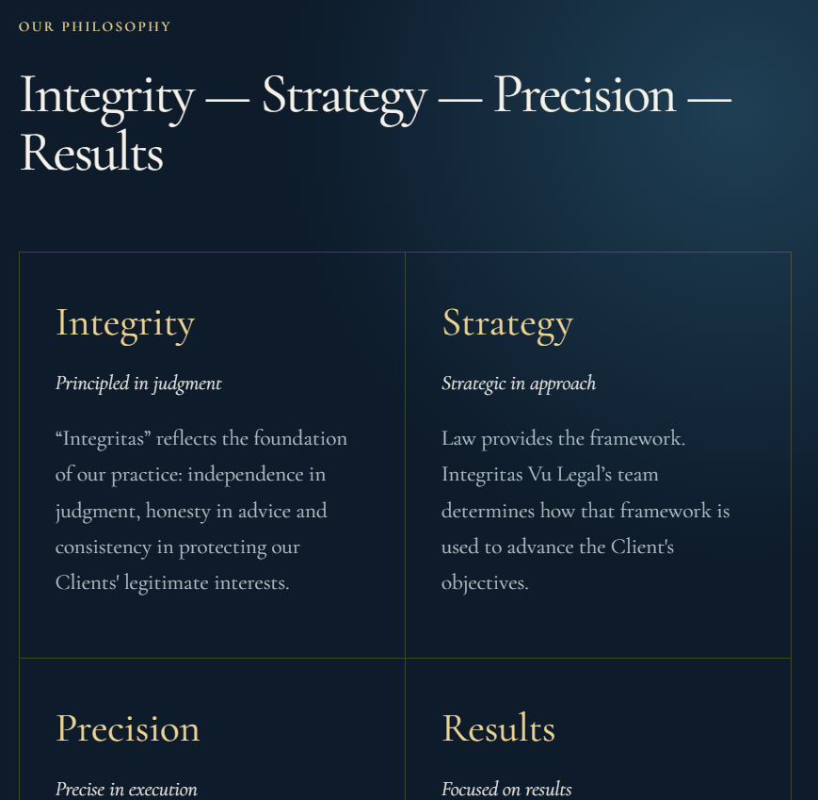 | Content của từng cái sửa lại thành:  INTEGRITY  Independent Judgment. Principled Advice.  Integrity is the foundation of our practice. We provide candid legal assessments, exercise independent professional judgment and uphold the principles of honesty, confidentiality and professional responsibility.  We believe that Clients are best served by advice that is objective, transparent and grounded in the law, even when that advice involves difficult considerations.  STRATEGY  Beyond Legal Questions. Towards Informed Decisions.  Legal challenges rarely exist in isolation. They often involve commercial relationships, financial consequences, reputational considerations and competing priorities.  We approach each matter strategically, evaluating not only what the law permits but also how different legal options may affect the Client's broader interests.  PRECISION  Rigorous Analysis. Disciplined Execution.  Precision is essential to effective legal practice.  From legal research and contractual drafting to evidence assessment, negotiation and advocacy, we place careful analysis and attention to detail at the centre of our work.  Our objective is to ensure that legal strategies are supported by sound reasoning and implemented with diligence.  RESULTS  Purposeful Action. Meaningful Outcomes.  We measure the value of our work by its relevance to the Client's objectives and the practical outcomes it seeks to achieve.  Whether preventing a dispute, completing a transaction, protecting an investment or pursuing a legal remedy, we remain focused on solutions that are legally sound, commercially sensible and realistically achievable.
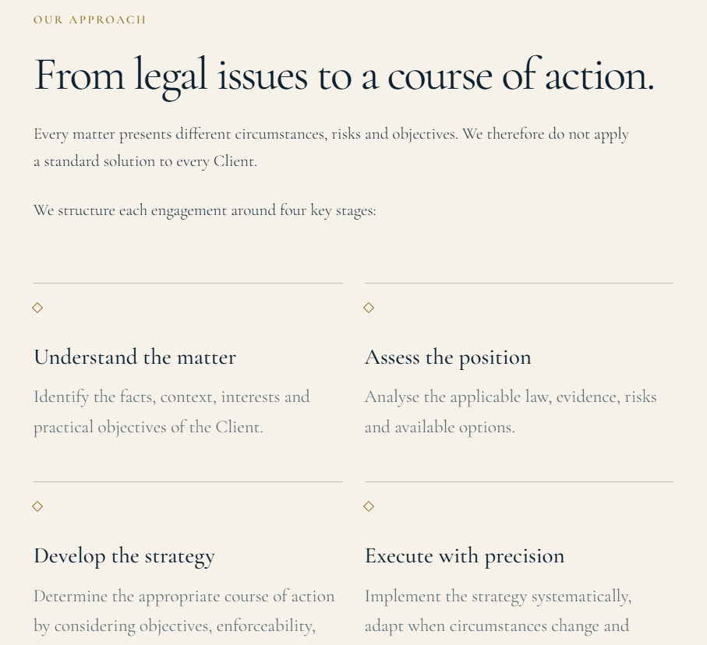 | Đổi content lại thành:  Every Matter Deserves Its Own Strategy.  There is no universal solution to a complex legal problem. Each engagement requires an understanding of the facts, the applicable legal framework and the interests at stake.  Our approach follows four essential stages.  01 — UNDERSTAND  Understanding the Matter and the Client.  We begin by examining the relevant facts, circumstances and legal relationships while identifying the Client's concerns, expectations and desired outcomes.  02 — ASSESS  Evaluating the Legal Position and Risks.  We analyse the applicable law, available evidence, potential liabilities and legal remedies. We also consider the commercial, financial and practical implications of each available option.  03 — DEVELOP  Formulating a Tailored Legal Strategy.  Drawing on our assessment, we develop a course of action aligned with the Client's priorities, taking into account legal feasibility, potential exposure, timing, costs and enforceability.  04 — EXECUTE  Implementing the Strategy with Precision.  We carry out the agreed strategy with diligence, maintain clear communication and reassess our approach as circumstances evolve.
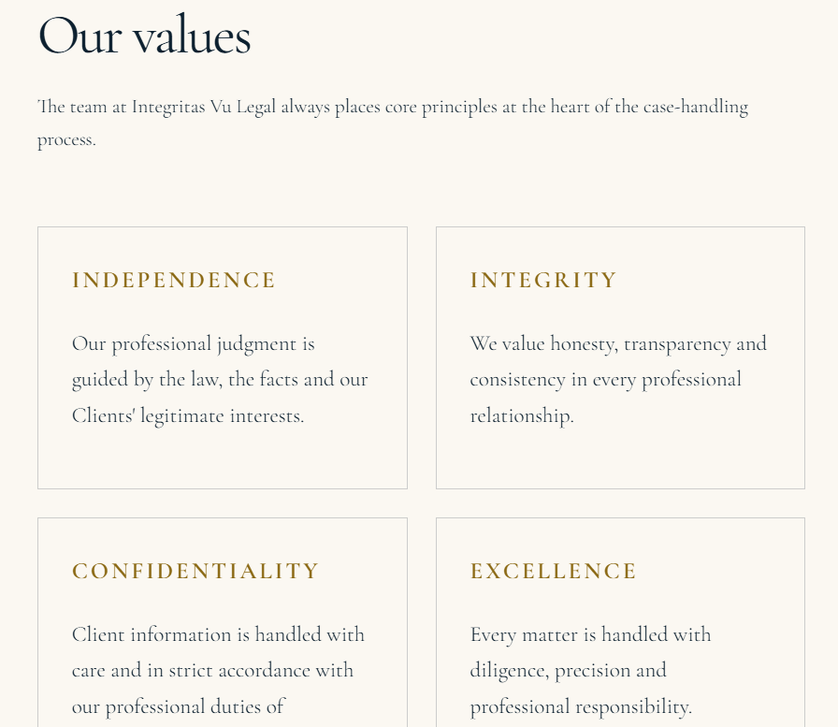 | Đổi content lại thành:  INDEPENDENCE  We exercise professional judgment based on the law, the facts and the legitimate interests of our Clients.  CONFIDENTIALITY  We recognise the sensitivity of the information entrusted to us and uphold our professional obligations to protect Client confidentiality.  RESPONSIBILITY  We approach every engagement with diligence, accountability and a commitment to the responsibilities entrusted to us.  PROFESSIONAL EXCELLENCE  We pursue high standards of legal analysis, preparation, communication and execution in every matter.  CLIENT COMMITMENT  We value long-term professional relationships built on trust, responsiveness and a clear understanding of our Clients' needs.
- Về form bên trang Contact, em link form tới mail contact thêm giúp chị nha: contact@integritasvulegal.com

